ANNUAL PROGRESS REPORT: 2013

Ghana (Phase 2)
Area: Public
Scope: GHG NIS, NAMAs, LEDS, MRV
Sectors: Energy
National Implementing Agency: Directorate for Environment, Ministry of Environment, Science and Technology and Innovation (MESTI)

The first Project Steering Committee meeting was held on 11 July, where committee members approved their Terms of Reference, as well as the 2013 work plan and budget. In the initial phase of project implementation, three project technical working groups (one for each project outcome) were created and met to agree on an implementation strategy for the three project outcomes and the coordination mechanisms to ensure timely deliverables.

Outcome1: Up to 2 financeable energy-related NAMAs formulated in the context of national development priorities, including the associated MRV system

Project partners held bilateral discussions with a number of energy-related organizations and companies (e.g. Volta River Authority, Energy Commission) to explore interest and potential opportunities for collaboration in NAMA development. Informal consultation meeting was held on 26 November to facilitate the selection of the two-energy related NAMAs. So far, out of the 12 identified, 5 have been prioritized. The five are (a) Promotion SMEs Participation Biogas Technology Penetration in Institutions, (b) Household and commercial EE promotion programs (bundling approach), (c) Incorporation of RE systems into households and commercial activities, (d) Establishment of market-based cleaner cooking solutions and (f) Off-grid electrification and access development (Refer to annex 1 for the report). In the first quarter of 2014, the formal consultation will be completed in order to select up-to-two NAMAs and well as establishment of the governance structure.

Outcome2: Ghana NAMAs Investor Guide reviewed and promoted among the business community

A team of consultants have initiated the review and the finalization of the NAMA Investor Guide under the guidance of the Ghana Investment Promotion Centre. In particular, the focus is to ensure that the quality and presentation of the information in the Guide has the potential to attract local and international private investments in climate change mitigation/development projects in Ghana. After the extensive consultation with businesses, international organisation (eg. DFID), associations (Private Enterprise Federation), public sector Institutions, NGO (ISODEC) etc., consultants have provide a revised draft version of the guide. In the first quarter of 2014, the consultation will be extended to the international community to solicit their inputs.

Outcome3: National system for preparation of GHG inventories strengthened
Design has commenced on the operational architecture and protocols for an online GHG inventory central database for documentation and archiving of all GHG inventory data. Documentation and archiving of the data is considered paramount for any future work in this area, to guarantee greater transparency and sustainability of the national inventory system and institutional memory. The database will be located at the Environmental Protection Agency (EPA).
Procurement and installation of all equipment and software have been completed. The database is undergoing testing and will be deployed to the targeted users and the general public in the first quarter of 2014. Snapshots of the online database template are attached annex 2.

Back-to-back workshop on GHG data management and establishment of MRV data sharing network was held. It was attended by 70 participants from 30 different public, private, research institutions and the universities (refer annex 3 for the comprehensive report). The workshops produced the following deliverables:

- A revised functional institutional arrangement for the domestic MRV.
- List of existing mechanisms for collecting and tracking data on implementation of mitigation actions.
- List of possible mitigation actions elicited from the sectors.
- Discussions and hands on exercise on the table format for reporting “mitigation actions” and “support” based on the CGE training materials.
- Completed GHG data improvement strategy template for the five inventory sectors.

Additional notes:
- Two representatives from the EPA and the Ministry of Finance participated in the LECB Annual Global Meeting held in Vietnam on 25-27 September where they presented on opportunities to scale up private sector engagement in climate change mitigation, in particular through the use of the NAMA Investor Guide.

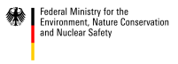 | 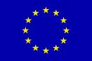 | 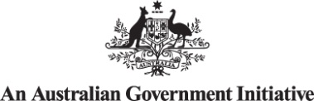

Annex 1 : Summary report on the Informal Consultation Meeting on the Preparation of Energy-related
NAMAs under the LECB Project

Date – 26th November, 2013

Location – Conference Room, Energy Commission

Participants
Mr. Kofi Agyarko Head, Energy Efficiency, Energy Commission
Mr. Otu Danquah Head, Renewable Energy, Energy Commission
Dr. Idun Biogas Technologies Expert
Mr. Fred Kenneth Appiah Energy Commission
Ms. Paula Edze Coordinator, SEA4ALL Secretariat, Energy Commission
Mr. Kennedy Amankwa Energy Commission
Mr. Peter Dery Ministry of Environment
Ing. Anthony Esiape Electricity Company of Ghana
Daniel Benefor Environmental Protection Agency

Purpose of meeting
- Informal consultation on the selection of energy related NAMAs
- Finalise the detail workplan of the NAMAs investor guide
- Discuss the term of reference of the working group

Informal consultation on the selection of energy related NAMAs
Based on agreed on set of criteria and national documentation, the group made a list of 13 possible energy NAMAs and further prune down to five (5). The detailed background information of the 5 will be prepared and used for further consultation and validation workshop. The initial list of possible NAMAs below:

Renewable Energy
- Wood-fuel supply chain improvement programme
  - Contained in the 55-list of NAMAs and the 5 prioritized NAMAs
  - Aligned with renewable energy act, the national energy policy
  - Contained in the SEA4ALL Action plan
  - Promotion of commercial or community-based woodlots
  - Improve charcoal production (charcoal carbonization)
  - 60% of primary energy consumption particularly in rural cooking.
  - Major source of GHG emissions, air pollution pollutants, source of health problems (Environmental benefits)
  - Opportunity for export of charcoal and feedstock must come from sustainable source
  - Value addition of wood product.
  - Regulation (charcoal export – Energy commission, management tree stock – Forestry commission, transformation to charcoal – EPA).

- Establishment of market-based cleaner cooking solutions
  - Aligned with renewable energy act, the national energy policy
  - Contained in the SEA4ALL Action plan
  - Promotion of downstream Improved cookstoves
  - LPG stove promotion programme
  - Standard and label for stoves
  - Global clean cooking stove initiatives in Ghana
  - Focus on entire supply spectrum of clean cooking solutions

- Promotion SMEs Participation Biogas Technology Penetration in Institutions
  - Flagship of the SEA4ALL Action Plan
  - Entire supply chain perspective
  - Constructing over 200 institutional biogas technology - schools, hospitals.
  - Potential for scaling up
  - Aligned with renewable energy act, the national energy policy
  - Reduce dependence on wood
  - Cost reduction
  - Improvement environmental sanitation (reduce cost of disposal)
  - Local content
  - Co-benefits (food security, water resource management)

- Solar – grid connected systems (supply side)
  - Aligned with renewable energy act, the national energy policy
  - Contained in the 55-list of NAMAs and the 5 prioritized NAMAs
  - FIT rates
  - Exist PPP models
  - Renewable energy fund
  - FIT offset fund (offset price disparities to promote greater penetration in the grid mix

- Incorporation of RE systems into households and commercial activities (demand side)
  - Aligned with renewable energy act, the national energy policy
  - Review building of the code
  - Involvement of start-ups or private SMEs
  - Use NAMAs as incentives
  - Establish guarantee or revolving funds
  - Could adopt the GEDAP approach

- Off-grid electrification and access development
  - Aligned with renewable energy act, the national energy policy and contained in the 55-list of NAMAs and the 5 prioritized NAMAs
  - Aligned with GEDAP
  - Universal electricity coverage by 2015
  - Community far away from the public grid could be the target of this option.
  - Such communities are the food basket of the nation.
  - Socio-economic developments in such communities are essential.
  - Cost of putting them on the grid is technically challenging and not cost effective.
  - Mini-grid using wind-solar-thermal (hybrid system) is being promoted apart of the universal policy target by 2015.
  - Up-scaling of the kerosene lamp replacement with solar lantern programme has additional scope.

- Productive use of energy under SEA4ALL - Wind/solar powered irrigation system
  - Flagship of the SEA4ALL Action Plan, FASDEP 2 and national energy policy
  - Wind/solar powered irrigation system in food growing parts of the country
  - Accessibility and reliability of services
  - Develop service hub to support network of food growing areas
  - Improve Incomes of target users
  - Food security
  - Reduce vulnerability to the negative impacts of climate change
  - Potential for SMEs

- Productive use of energy under SEA4ALL – RE-powered drying systems to support economic activities in fishing communities
  - Wind/solar can support community-based economic activities (fisheries)
  - Accessibility and reliability of services
  - Develop service hub to support network of fishing communities
  - Improve Incomes of target users
  - Food security
  - Potential for SMEs

- 10% biofuel blend
- New policy directive.
- Policy must be in place to promote biofuel blend
- The blend in the RE act
- Consider entire biofuel supply chain
- Barriers in the update because policy has been rooted.

Demand side management (Energy Efficiency)
- Household level education programme on electricity conservation
  - Aligned with renewable energy act, the national energy policy and
  - Contained in the 55-list of NAMAs and the 5 prioritized NAMAs
  - Aligned with SEA4ALL EE improvement goals
  - Reduction on end user electricity conservation
- Promote energy saving practices especially during peak hours.
- Benefits to reducing electricity waste
- Cost saving – electricity bills

- Household and commercial EE promotion programs (bundling approach)
  - Installation of Photo cells for households
  - Capacitors in industry/commercial (power factor correction programme)
    - Review the power factor surcharge upwards
    - Scale-up of on-going power factor correction programme
    - Energy audit for the SLTs

- Embedded solar street lighting system
  - Aligned with street light policy, RE Act,
  - Energy saving opportunities
  - wheel power to the grid
  - reduced emission from electricity generation
  - contribute to electricity reliability from street lighting

- Fridge rebate scheme – expand the scope
  - Mechanism to consider first time buyers
  - Promote penetration of solar fridges using DC devices

Pruning of idea areas into 5
The meeting further pruned the 13 options into 5 based on the criteria below and alignment with the following national documents:
- Ghana shared growth development agenda
- National energy policy
- SEA4ALL Action Plan
- National Climate Change Policy and 5 sector strategies
- 55 list of NAMAs and 5 further prioritized NAMAs

The criteria used are below:
- Emission reduction potential
- Alignment of existing policies and programmes, ongoing processes and
- Must be contained in the list 55 NAMAs
- Acceptability of the selected NAMAs by the project actors/ beneficiaries.
- Scalability – not start from ground zero
- Cost-effectiveness
- Technology potential
- Market feasibility
- Co-benefits (SD)
- Data availability
- Easy to implement or scale up
- Barriers

5 NAMAs selected in order of priority:
- Promotion SMEs Participation Biogas Technology Penetration in Institutions
- Household and commercial EE promotion programs (bundling approach)
- Incorporation of RE systems into households and commercial activities (demand side)
- Establishment of market-based cleaner cooking solutions
- Off-grid electrification and access development

What next
- Workplan – 3 activities will be done by the end of the year. Two activities will focus on doing the background information and the establishing the governance structure of the selected NAMAs. The papers that will emerge from the preliminary will be used as input in the “consultation meeting” will be held in the first quarter of 2014.
  - EPA was tasked to clean up the identified NAMAs and bounce it back to the members for comments.
  - EPA is to do the preliminary paper work on consultation meeting. This will include location, list of participants and the agenda of the meeting. Then the working group members will then review to provide input where necessary. Especially with respect to the list of participants, the members of the working group are expected to provide list of potential participants.

  - With respect to the preparation of the background materials, energy commission was asked to lead and liaise with the consultants that will be selected to undertake the review policies and ongoing national processes that will be relevant for the selected NAMAs. MESTI, EPA and ECG were tasked to lead and liaise with the selected consultants to do the background materials on the governance structure of the selected NAMAs.

Prepared by Daniel Benefor
---END---

Annex 2: Snapshots of the GHG online database design
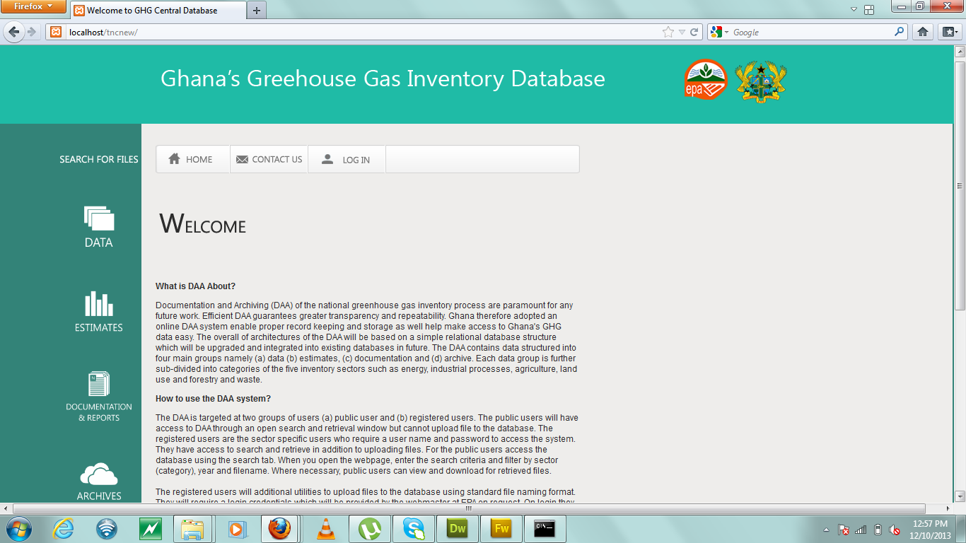
- Home Page
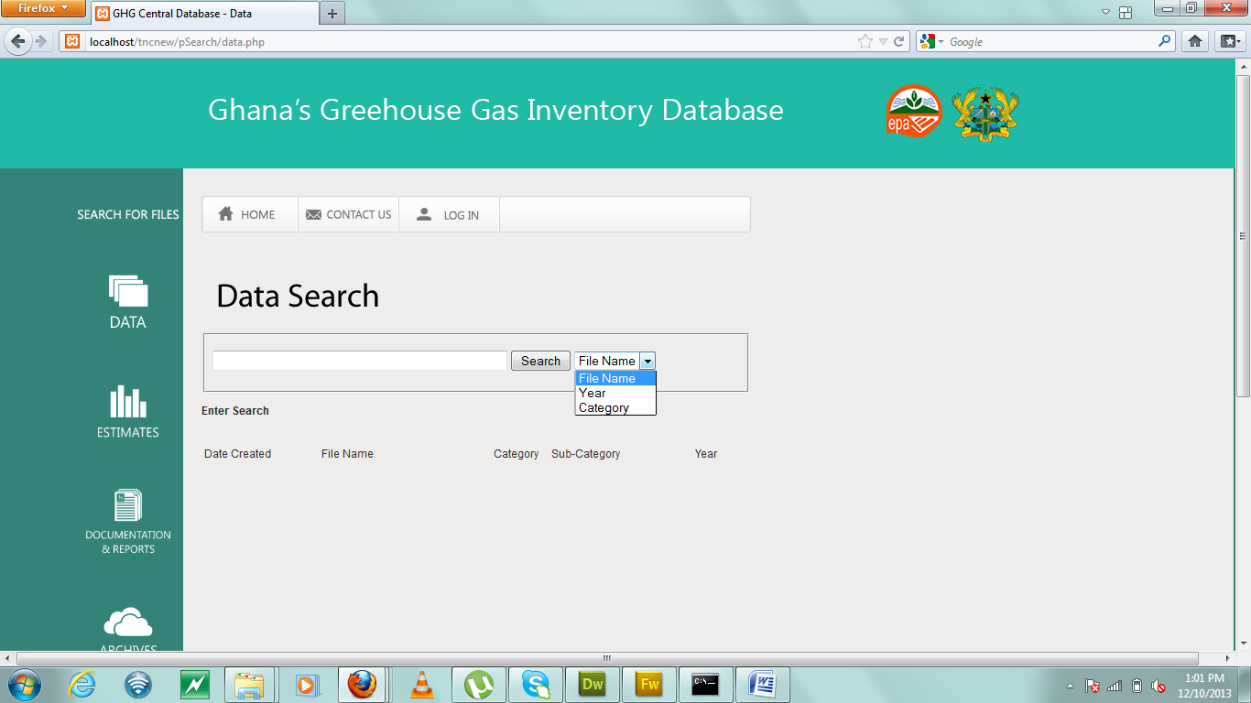
- Search Page for Public

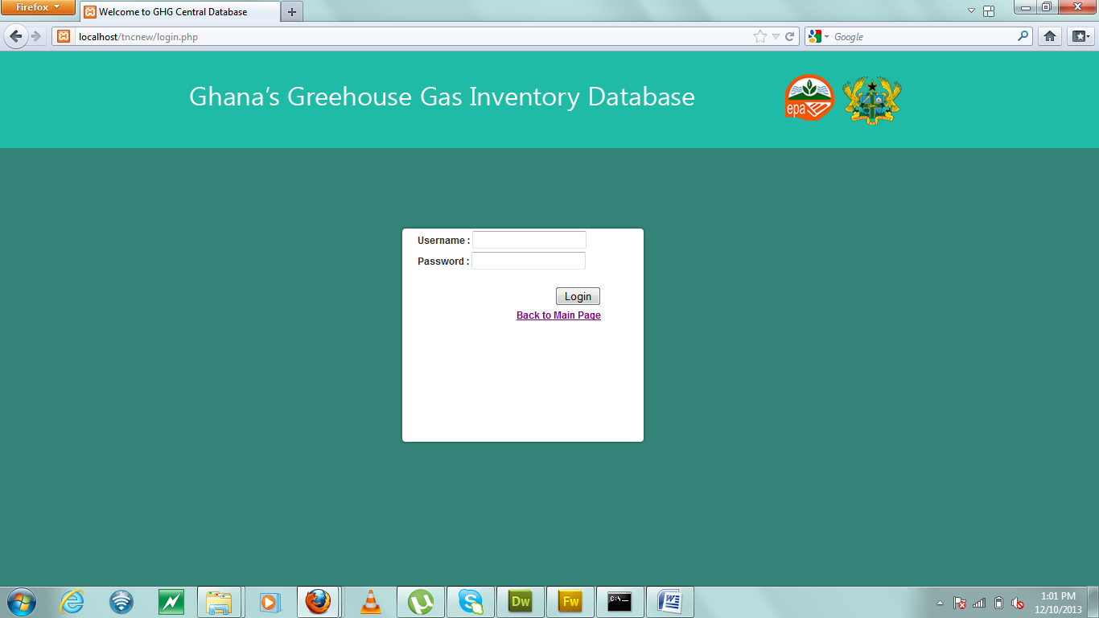
- Login Page
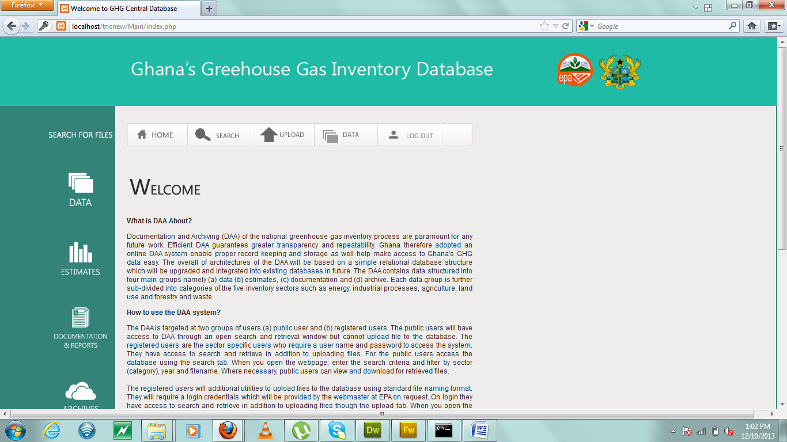
- Main Page for Registered Users

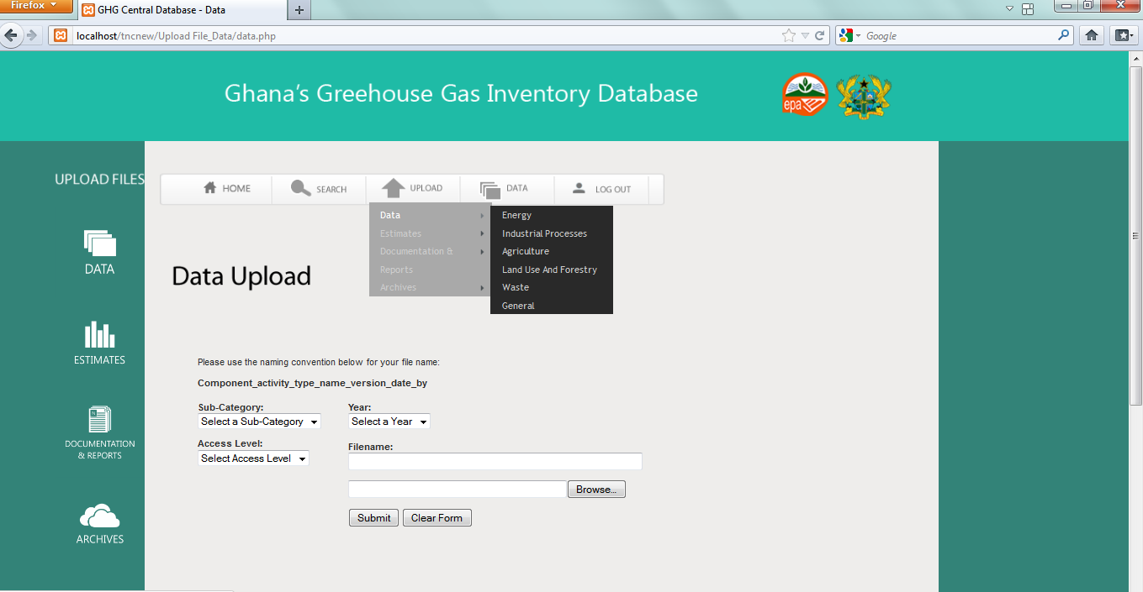
- Upload Page showing Groups with Sector
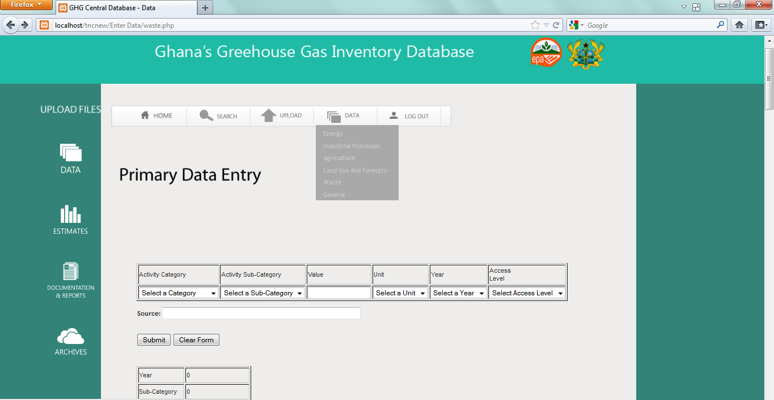
- Primary Data Entry Page

